Contributor: Maria Bernardete Ramos Flores

**Nery, Ismael**

Born: 1900 – Belém do Pará; Died: 1934 – Rio de Janeiro, Brasil

Ismael Nery was one on the most remarkable artists of Brazilian Modernism, but little known during his own time. By rejecting the representational canons used during the early twentieth century to give visibility to national themes, Nery produced a mystic and visionary art, more comparable, in philosophical terms, to the principles outlined by **Kandinsky** in his *Concerning the spiritual in art* (1912)*.* Nery went to Europe twice. During his first stay in Paris, in 1921, he enrolled in the *Academie Julian*. The contact with the artistic avant-gardes and with the Parisian museums clearly influenced his artistic production. It is possible to identify aspects of the Pre-Raphaelite style in his work, of the sinuous lines of **Aubrey Beardsley**, of premises of Symbolism, and of **Picasso**’s Cubism; there are also references to **Magritte**’s paradoxes, to **Matisse**’s two-dimensionality and to the surreal compositions and metaphysical art of **De Chirico**. In his second trip to Paris, in 1927, Nery met **André Breton** and became close to **Marc Chagall**, a fact that produced resonances in several of his aerial and oneiric figures. The main theme of Nery’s painting is human figures in fractured, juxtaposed compositions. He uses repeated physiognomies and an iconography that ranges from angels to devils, from mystic to erotic, from perfect to distorted and dilacerated anatomies.

Ismael Nery, along his short artistic trajectory, limited to a little longer than a decade (1920-1933), was strongly influenced by his mother’s religiosity. Nery’s mother, mentally ill after the premature death of her husband (a brilliant doctor and researcher) and her eldest son at only 18 years of age (from the Spanish flu), became a nun and joined the religious Third Order of San Francisco. He often used himself as a model as well as his wife, the poet Adalgisa Nery. At times his friend, the poet Murilo Mendes, and occasionally his mother, also became models in his successive portraits of human pairs or triangles, usually made up of one man and two women.

To Nery, art was a means to express his spiritual and philosophical restlessness. His project of disintegration of the pictorial body arose from the desire to find the essence of the form through the abstraction of time and space. In *IN’s Self-Portrait* – 1927, the figure of the artist himself sitting on an aerial chair divides the room in two spaces: on the right, a Parisian landscape with the Eiffel Tower, and, on the left, the Sugar Loaf representing the scenery of Rio de Janeiro. The juxtaposition of the Eiffel Tower and the Sugar Loaf, with contours of the artist, expressed temporal and spatial simultaneity.

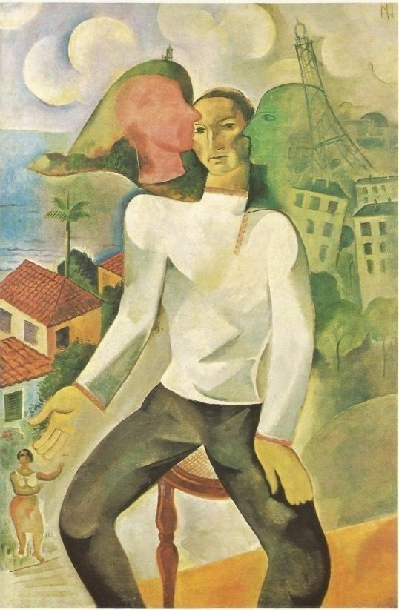

Ismael Nery. *Auto-retrato* (*IN’s Self-Portrait*), 1927, oil on canvas, 51,60 X 33,60 inches, collection Domingos Giobbi, São Paulo, Brasil.

http://www.itaucultural.org.br/aplicExternas/enciclopedia_IC/index.cfm?fuseaction=artistas_obras&cd_verbete=900&cd_idioma=28555

Another interesting aspect in Ismael Nery is the androgynousness that pervades much of his work. In *Self-Portrait* (1925), the artist appears with a white, loose blouse, the right hand resting on his chest bearing a large round ring. His long fingers, painted nails, mouth with lipstick, almond-shaped eyes, and the hair dropping very much reminds one of his wife’s hair in many of his portraits of her. In *Women sitting with a bunch of flowers* (1927), the most sensual feminine representation in Nery’s work, the facial physiognomy of his self-portraits is repeated. While in *Androgynous* (s/d), a vertical line divides the contour of the face; the masculine half plays with the appearance of Nery is his self-portraits, the other half reminds us of his wife’s portraits. In these works, the artist uses the androgynous figures as signs of totality to evoke a notion of universal time. Within this notion of universal androgyny as a consequence of the divine androgyny is the conception that perfection arises from unit-totality. And it is not by chance that in *Self-Portrait Christ* (1923) the painter transposes his own physiognomy into an image of an androgynous Christ.

At age 30, Nery found out he was suffering from tuberculosis and influenced by the imaginary of his illness, the artist produced beautiful works in a Surrealist style, depicting disfigured and visceral anatomies that sometimes remind us of mechanic or hydraulic objects, as we can observe in *Internal Vision - agony*, 1931. This later period was the artist’s most productive time, Nery began to engage narrative both in his writings and drawings; the result is spectacular series such as *Miserabilia* and *Hystory of Ismael Nery*, where he prefigures his own death and funeral. Per his dying wish, at age 33, Ismael Nery was buried with the habit of the religious order his mother had joined in his youth, the Order of San Francisco.

**Further Reading:**

Amaral, Aracy (1984) *Ismael Nery 50 anos depois*. São Paulo: AC-USP.

Bento, Antônio (1973) *Ismael Nery*. São Paulo: Gráficos Brunner Ltda.

Cordeiro, André Teixeira (2008) *Pássaros de carne e lenda: a poesia plástica de Ismael Nery e Murilo Mendes*. Tese de Doutorado: Faculdade de Filosofia, Letras e Ciências Humanas (FFLCH). USP, Brasil.

Kandinsky, Wassily. *Concerning the spiritual in art.* Traslated by M.T.H. Sadler. New York: Dover Publications, Inc.: 1977.

Mattar, Denise (2000) *Ismael Nery 100 anos: a poética de um mito*. São Paulo: Centro Cultural Banco do Brasil; Fundação Armando Álvares Penteado.

Mattar, Denise (2004) *Ismael Nery*. Rio de Janeiro: Banco Pactual S.A./ Lei de Incentivo à Cultura/Ministério da Cultura.

Munari, Luiz (1983) *Ismael Nery. Pinturas e Fábulas*. Tese de Mestrado: Faculdade de Filosofia, Letras e Ciências Humanas (FFLCH). USP, Brasil.

Barbosa, Leila M. F. & Rodrigues, Marisa T. P (2009). *Ismael Nery e Murilo Mendes: reflexos.* Juiz de Fora (MG): UFJF/MAMM.

**List of Works:**

Ismael Nery, *Auto-retrato Cristo* (*Self-portrait Christ*), 1923, oil on canvas glued to wood, 12,70 X 9,80 inches, collection Chaim José Hamer, São Paulo (SP) - Brasil.

Ismael Nery, *Mulher sentada com ramos de flores* (*Women sitting with a bunch of flowers*)*,* 1927, oil on card, 24,64 X 21,32 inches, collection Cosette Alves.

Ismael Nery, *Visão interna – agonia* (*Internal vision – agony*), 1931, oil on card, 27,65 X 18,65 inches. collection Chaim José Hamer (São Paulo, SP – Brasil).

Ismael Nery, *Andrógino* (*Androgynous*), undated, watercolor on paper, 10,90 X 8,30 inches, collection Luís Fernando Nazarian, São Paulo, Brasil.

Ismael Nery, *Auto-retrato* ( *Self-portrait*), 1925, gouache on paper, 6,2 X 3,7 cm. collection Gilberto Chateaubriand, Rio de Janeiro, Brasil.